1. All the images needed is in the attached assignment if you use our design else use any pages you created earlier in the previous assignments. I am not worried about exact colors/background colors so use your creativity to have right colors.
2. Create a 2 column layout of Coffeehouse or the website you created in previous assignment similar like given below and use fixed position for the menu item so it stays when you scroll.

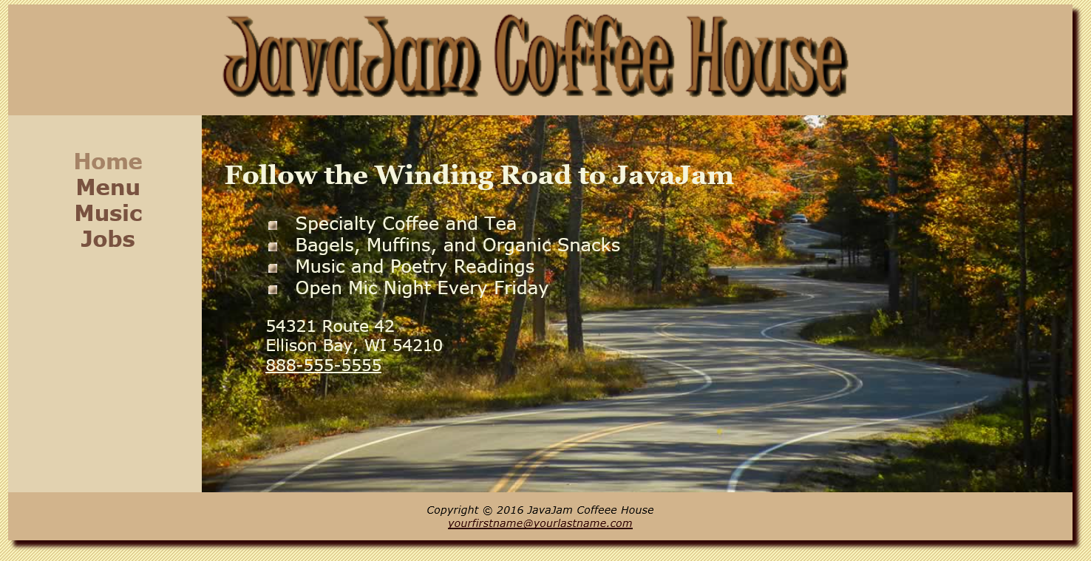

1. Now add another page where this menu item is horizontal using display:inline
2. Use CSS pseudo classes discussed in the class for the links
3. Add a table to one of the page and use CSS structural pseudo class
4. Create an image gallery like we did a lab in the class on one of the page of the website